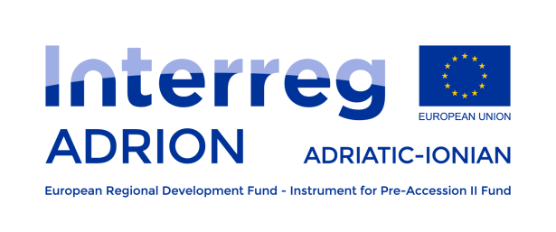

Interreg V-B ADRIATIC IONIAN
TRANSNATIONAL COOPERATION PROGRAMME 2014-2020
“ADRION”

Fifth Extraordinary call for proposals
Programme Manual
Priority Axes 1 and 2

Version 1: June 2022

Disclaimer:
The present manual intends to provide useful information for applicants. It does not replace or overrule the official EU Regulations and Adriatic Ionian Cooperation Programme.

List of acronyms

ADRION | INTERREG V-B Adriatic-Ionian Transnational Cooperation Programme 2014 - 2020
AF | application form
CP | cooperation programme
ENI | European Neighbourhood Instrument
ESI FUNDS | European Investment and Structural Funds
ERDF | European Regional Development Fund
ETC | European Territorial Cooperation
EUSAIR | European Union Strategy for Adriatic and Ionian Region
ERDF Partner States | Croatia, Greece, Italy, Slovenia
ICT | information and communication technologies
IP | investment priority
IPA | Instrument for Pre-Accession Assistance
IPA Partner States | Albania, Bosnia and Herzegovina, Montenegro, Serbia
JS | joint secretariat
MA | managing authority
MC | monitoring committee
NCP | national contact point
PA | priority axis
Partner States | Albania, Bosnia and Herzegovina, Croatia, Greece, Italy, Montenegro, Serbia, Slovenia
PRAG | Practical Guide to Contract Procedures for EU External Actions
SME | Small and Medium sized Enterprises
SO | specific objective
TO | thematic objective
Lead Partner, Lead beneficiary and Lead applicant have been used as synonyms
Project Partner and project beneficiary have been used as synonyms
Operation and project have been used as synonyms

Table of contents

Introduction 5
1. GENERAL INFORMATION ON THE ADRIATIC-IONIAN TRANSNATIONAL PROGRAMME 6
1.1 Legal and strategic framework 7
1.2 The ADRION programme in a nutshell 9
The Programme eligible area 9
ADRION programme budget 10
ADRION Cooperation Programme structure 10
1.3 Outputs - What the Programme funds 11
1.4 The EU Strategy of the Adriatic and Ionian region - EUSAIR 11
Links between the EUSAIR and ADRION Programme 13
1.5 Programme key principles 13
1.6 Horizontal principles 14
Equality between men and women and non-discrimination 14
Sustainable development 15
1.7 Programme language 15
2. FIFTH EXTRAORDINARY CALL FOR PROPOSALS DEVOTED TO PRIORITY AXES 1 AND 2: KEY ELEMENTS 16
2.1. Overall goal 17
2.2. EU funds allocation 18
2.3. EU Project financial size 18
2.4. Eligible financing project partners 18
Additional requirements 19
Exclusion from participation 20
2.5. Eligible project partnership 20
Other forms of participation within the projects – associated partners 21
2.6. Ways of cooperation within a project proposal 21
2.7. Location of the operation and related activities 22
2.8. Project duration 22
2.9. Funding method 23
2.10. Project budget 23
Use of Euro 23
2.11. Hierarchy of rules on eligibility of expenditure 24
2.12. General eligibility requirements 24
2.13. Project budget lines 26
Staff costs 27
Office and administrative expenditure 29
Travel and accommodation costs 29
External expertise and services costs 31
Equipment expenditure 32
3. PROCEDURE FOR SUBMISSION AND SELECTION OF OPERATIONS 34
3.1. Publication 35
3.2. Submission of project proposals 35
3.3. Application Form 36
Project summary 36
Project partners 36
Project description 37
Work plan 41
Non-compulsory work packages 44
Partner budget 45
Project budget overview 46
3.4. Assessment of the applications 46
Admissibility and eligibility check 46
Anti-fraud check 49
Exclusion of presence of double funding 49
Finalization of the project assessment grid 50
3.5. Decision making and communication to the Lead Applicants 50
3.6. Contractual provisions 50
Principle of non-cumulative award (double funding) 50
Subsidy Contract 51
Exclusion from subsidy 51
Partnership Agreement 51
3.7. Advance payment 51
Payment procedure 52
3.8. Publicity by the Programme 52
3.9. Complaint procedure 52
3.10. Data Protection 53
3.11. Contacts 53

Introduction
This Programme Manual is based on the legal framework establishing the ESI Funds, the Interreg V-B Adriatic Ionian Transnational Programme (ADRION) and the decisions adopted by the ADRION Monitoring Committee (MC).
It intends to give guidance to potential beneficiaries interested in submitting project applications in the framework of the fifth extraordinary call for proposals, which will be addressed to Priority Axes 1 and 2.

The present document is structured according to the following: section 1 provides a general overview on the programme, whereas sections 2 and 3 are targeted to the fifth extraordinary call elements and requirements.

GENERAL INFORMATION ON THE ADRIATIC-IONIAN TRANSNATIONAL PROGRAMME

Legal and strategic framework
The points below provide an overview (non-exhaustive list) on the legal framework supporting the Interreg V-B transnational programme (ADRION); eventual amendments of the listed Regulations must be considered as well:
- Regulation (EU) No 1303/2013 of the European Parliament and of the Council of 17 December 2013 laying down common provisions on the European Regional Development Fund (ERDF), the European Social Fund, the Cohesion Fund, the European Agricultural Fund for Rural Development and the European Maritime and Fisheries Fund and laying down general provisions on the European Regional Development Fund, the European Social Fund, the Cohesion Fund and the European Maritime and Fisheries Fund and repealing Council Regulation (EC) No 1083/2006;
- Regulation (EU) No 1301/2013 of the European Parliament and of the Council of 17 December 2013 on the European Regional Development Fund and on specific provisions concerning the Investment for growth and jobs goal and repealing Regulation (EC) No 1080/2006;
- Regulation (EU) No 1302/2013 of the European Parliament and of the Council of 17 December 2013 amending Regulation (EC) No 1082/2006 on a European grouping of territorial cooperation (EGTC) as regards the clarification, simplification and improvement of the establishment and functioning of such groupings;
- Regulation (EU) No 1299/2013 of the European Parliament and of the Council of 17 December 2013 on specific provisions for the support from the European Regional Development Fund to the European territorial cooperation goal;
- Regulation (EU) No 231/2014 of the European Parliament and of the Council of 11 March 2014 establishing an Instrument for Pre-accession Assistance (IPA II);
- Regulation (EU) No 236/2014 of the European Parliament and of the Council of 11 March 2014, Common Implementing Regulation for External Actions;
- Regulation (EU, Euratom) 2018/1046 of the European Parliament and of the Council of 18 July 2018 on the financial rules applicable to the general budget of the Union, amending Regulations (EU) No 1296/2013, (EU) No 1301/2013, (EU) No 1303/2013, (EU) No 1304/2013, (EU) No 1309/2013, (EU) No 1316/2013, (EU) No 223/2014, (EU) No 283/2014, and Decision No 541/2014/EU and repealing Regulation (EU, Euratom) No 966/2012;
- Delegated and Implementing Acts of the European Structural and Investments Funds Regulations for the period 2014-2020;
- EU legislation and related underlying principles laying down provisions on public procurement, on competition and entry into the markets, the protection of the environment, the equal opportunities between men and women and non-discrimination;
- Art. 107 and 108 of the Treaty on the Functioning of the European Union;
- Commission Regulation (EU) No 1407/2013 on the application of art. 107 and 108 of the Treaty on the functioning of the European Union to de minimis aid;
- Delegated and Implementing acts as well as all applicable decisions and rules in the field of state aid.

In addition to the above, the lead and project partners (hereinafter: LP and PP) must also take into account the following:
- The European Territorial Cooperation Programme Interreg V-B Adriatic Ionian CCI 2014TC16M4TN002, approved by the European Commission on 20/10/2015 in its latest version;
- The Interreg ADRION Programme Strategic Environmental Assessment;
- The Call announcement of the present fifth extraordinary call for proposals.
- National rules applicable to the beneficiaries and their activities;
- The laws of the Republic of Italy applicable to the contractual relationship between MA and the LP.

The application package of the fifth extraordinary call for proposal is available on ADRION web site.

For reference and further documentation please consult the following websites:
http://ec.europa.eu/regional_policy/en/information/legislation/regulations/
http://ec.europa.eu/regional_policy/en/information/legislation/delegated-acts/
http://ec.europa.eu/regional_policy/en/information/legislation/implementing-acts/
http://ec.europa.eu/enlargement/instruments/overview/index_en.htm

The ADRION programme in a nutshell
The ADRION overall objective is to act as a policy driver and governance innovator fostering European integration among Partner States (Albania, Bosnia and Herzegovina, Croatia, Greece, Italy, Montenegro, Serbia, Slovenia), taking advantage from the rich natural, cultural and human resources surrounding the Adriatic and Ionian seas and enhancing economic, social and territorial cohesion in the Programme area.
ADRION intends to contribute to “the harmonious development of the Union’s territory (…) and to strengthen cooperation by means of actions conducive to integrated territorial development linked to the Union’s cohesion policy priorities” through the funding of project proposals aimed at positively contributing to the needs and challenges of the living conditions in the ADRION area (economic activities, quality of the environment, safety, etc.), rather than highlighting on the needs of a limited number of partners.

The Programme eligible area
The ADRION Programme includes a wide transnational area with more than 70 million inhabitants, and has distinct physical, environmental, socio-economic and cultural characteristics. Hence, it addresses all three dimensions of sustainability, including social, economic and environmental aspects but also institutional elements.
The Programme eligible area involves 8 Partner States primarily surrounding the Adriatic and Ionian Sea basin and covering an important terrestrial surface as well. Four countries are EU Member States, whereas the other four are candidate or potential candidate countries.
EU Partner States:
- Croatia (NUTS regions: Jadranska Hrvatska; Kontinentalna Hrvatska);
- Greece (NUTS regions: Anatoliki Makedonia, Thraki; Kentriki Makedonia; Dytiki Makedonia; Thessalia; Ipeiros; Ionia Nisia; Dytiki Ellada; Sterea Ellada; Peloponnisos; Attiki; Voreio Aigaio; Notio Aigaio; Kriti);
- Italy (NUTS regions: Abruzzo, Basilicata, Calabria, Emilia-Romagna, Friuli-Venezia Giulia, Lombardia, Marche, Molise, Provincia Autonoma di Bolzano, Provincia Autonoma di Trento, Puglia, Sicilia, Umbria, Veneto);
- Slovenia (NUTS regions: Vzhodna Slovenija; Zahodna Slovenija).

Non-EU Partner States:
- Albania;
- Bosnia and Herzegovina;
- Montenegro;
- Serbia.

As a general rule, EU Member States benefit from ERDF funds (hereinafter: ERDF Partner States), whereas the others from IPA II (IPA) contribution (hereinafter: IPA Partner States).

ADRION programme budget
The overall programme budget amounts to EUR 117.918.198, out of which EUR 99.156.616 of EU public resources (EUR 83.467.729 ERDF and EUR 15.688.887 IPA funds).
Funds devoted to operations to be allocated through calls for proposals refer to the three priority axes:
- Priority Axis No 1 - Innovative and smart Region;
- Priority Axis No 2 - Sustainable Region;
- Priority Axis No 3 – Connected Region.

ADRION Cooperation Programme structure
As all the Cooperation Programmes approved in the 2014-2020 programming period, also ADRION is based on a result-oriented approach and follows a programme intervention logic aimed at defining its structure and goals in accordance with the Regulation (EU) No 1299/2013.
The result-oriented approach is based on:
- Result orientation of the programme;
- Programme monitoring through indicators;
- Evaluation and reporting.
The programme intervention logic is the theoretical framework that structures and visualises the entire logical and sequential process adopted by the programme to define its thematic and specific objectives aimed at contributing to reaching the expected change within the programme area.
The programme structure is characterised by Priority Axes, Programme Specific Objectives, actions to be supported, outputs and results each other closely interlinked:
- A priority axis corresponds to a thematic objective as described in art. 9 of the Regulation (EU) No 1303/2013 and to art. 5 of Regulation (EU) No 1301/2013;
- Each priority axis includes specific objectives and expected results for the specific objectives;
- Descriptions of the type and examples of actions to be supported under each investment priority and their expected contribution to the specific objectives;
- Output indicators including their quantified target value, which are expected to contribute to the results (e.g.: number of firms supported, number of action plans elaborated, etc.);
- Result indicators relating to the specific objectives of the Priority Axis. They refer to the effects on direct beneficiaries brought about by the programme. They provide information on changes to, for example, the behaviour, or the capacity or performance of beneficiaries. Such indicators can be physical (e.g.: reduction of energy consumption, increase of a competence etc.) or financial (e.g.: additional financial resource mobilised, decrease of an expense etc.).

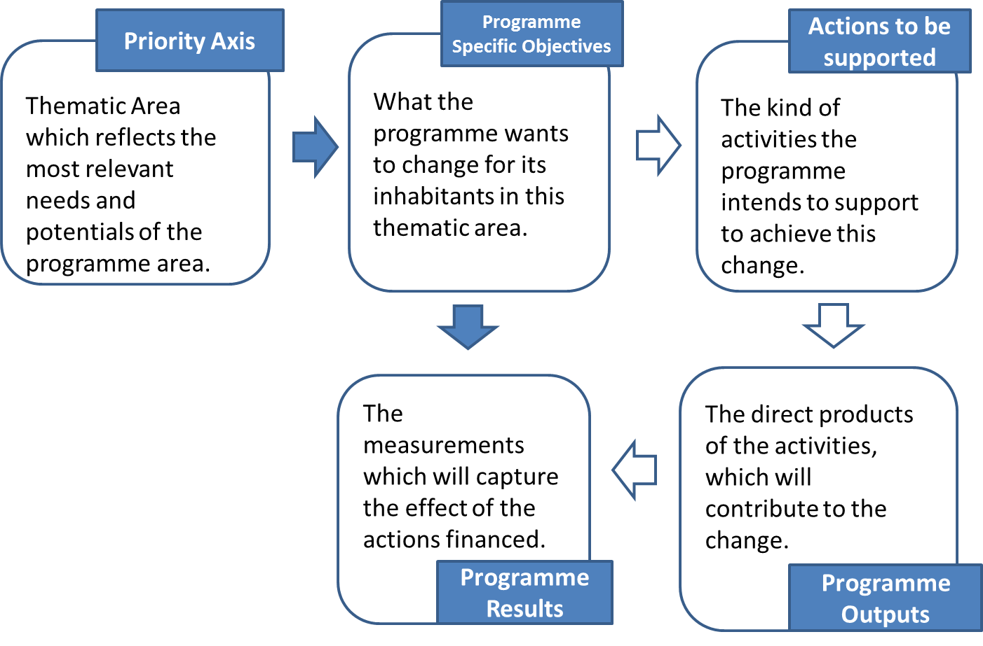

Outputs - What the Programme funds
As reported in the previous paragraph, outputs indicators are used to measure the direct products (outputs) of supported projects, which in turn contribute to result.
Identified outputs are aimed at supporting the achievement of the desired changed.
Overall, ADRION shall support the delivery of the following outputs:
- Networking structures;
- Joint management systems and cooperation agreements;
- Strategies and Action Plans;
- Methodologies and Tools;
- Pilot Actions (Number of small scale investments and demonstration projects).

Outputs must be developed, adopted and implemented within the project lifetime.
The realization of these outputs shall have to be attested by adequate supporting documents.
Specific reference to the outputs to be delivered in the framework of the present call for proposals is provided in the following pages.

The EU Strategy of the Adriatic and Ionian region - EUSAIR
The geographical area covered by the ADRION Programme coincides with the one encompassed by the EU macro-regional strategy for the Adriatic Ionian Region (EUSAIR), which offers a framework for policy coordination reflected in a joint action plan shared between several countries or regions.
A macro region is an area including the territory of several countries or regions which shares common features or challenges.
The EUSAIR was jointly developed by the countries and stakeholders of the Adriatic-Ionian Region with the support of the European Commission. EUSAIR was finally endorsed by the European Council in October 2014, to identify and address common challenges together.
Through the development and implementation of EUSAIR, the Partner States aim at fostering coordination of interventions across all territories and policy areas in the Adriatic-Ionian Region and to add value to those actions which significantly contribute to address joint challenges and opportunities.
The Strategy is structured into 4 pillars; its action plan identifies topics for joint actions, defines the related targets and will be periodically revised to take into account achievements and changes in the Region.

The Strategy encourages a horizontal approach, highlighting interdependence between its four pillars.

EUSAIR is one of the four macro regional strategies put in place; the others are:
- The EU Strategy for the Baltic Sea Region (EUSBSR);
- The EU Strategy for the Danube Region (EUSDR);
- The EU Strategy for the Alpine Region (EUSALP).

Updated information on the EUSAIR strategy can be found in:
- http://ec.europa.eu/regional_policy/en/policy/cooperation/macro-regional-strategies/adriatic-ionian/
- http://www.adriatic-ionian.eu/.

Links between the EUSAIR and ADRION Programme
ADRION programme must be seen as a strategic programme due to its direct alignment - geographically, thematically, and operationally - to the EU Strategy for the Adriatic and Ionian Region.
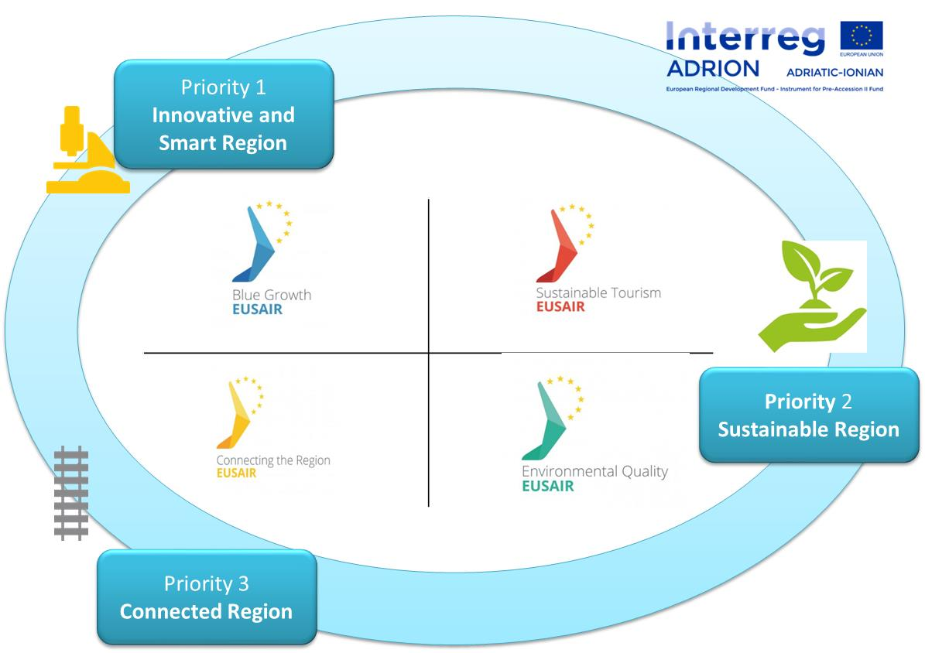

Priority Axis 1 on innovation directly addresses Pillar 1 on Blue Growth but also encompasses elements of the other three Pillars;
Priority Axis 2 on natural and cultural heritage and biodiversity directly addresses Pillar 4 on Sustainable Tourism through the Investment Priority (IP) 6c, but also Pillar 1 on Blue Growth and 3 on Environmental Quality through IP 6d;
Priority Axis 3 on sustainable transport and mobility directly addresses Pillar 2 on connecting the Region and indirectly Pillar 3 through the promotion of environmental-friendly low carbon transport and also Pillar 4 as a prerequisite for tourism.
However, it should be highlighted that the alignment is not comprehensive, as not all the ADRION topics are present in EUSAIR, and not all EUSAIR ones are mirrored in ADRION.

Programme key principles
ADRION Programme does not start from scratch: it has its roots in the projects mainly funded by the transnational programme South East Europe and by the IPA cross-border Adriatic programme in the area.
A wide variety of actors have been involved on both Adriatic and Ionian coastlines as well as on its bordering terrestrial surface and a wealth of knowledge, experiences, innovative practices, valuable outputs and results have been generated and must not be dispersed: indeed, they shall be taken into account and capitalised to progress in cooperation and achievements.
In this respect the ADRION programme intends to consolidate the capital built by Interreg projects and programmes with the objectives of:
  - Making the knowledge and results generated by projects more accessible, thus improving transfer of knowledge;
  - Obtaining additional results through benchmarking and detailed content analysis, building on existing knowledge and experience;
  - Promoting the re-use and/or transfer of this knowledge and these results, in order to boost performance and delivery.
  - Raising awareness and improving communication of results in specific fields of regional policy.

This approach shall support the leading principles guiding the ADRION implementation which can be summarised as follows:
  - Effective contribution of funded operations to the programme results through the realization of programme outputs;
  - Positive contribution to the needs and challenges in a transnational perspective of the living conditions in the ADRION area (economic activities, quality of the environment, safety, etc.), rather than highlighting on the needs of a limited number of partners;
  - Support the exchange and transfer experiences between regions, transnational interventions and capacity building, and ensure that results are disseminated and used beyond project partners;
  - (Relevance of) cohesion policy and capacity building as multiplier of prosperity and growth;
  - Leverage for future initiatives and investments.

Horizontal principles

Equality between men and women and non-discrimination
In addition to the thematic orientation, ADRION Programme incorporates horizontal aspects highlighted in EU regulations, namely:
- Equal opportunities and non-discrimination:
Projects must ensure that the activities implemented do not generate sex discrimination of any kind (sex, racial or ethnic origin, religion or belief, disability, age or sexual orientation) and to explain how the equal opportunity principle is rooted in the project design and implementation. All projects, regardless the priority axis under which they are submitted are encouraged to foresee measures or actions to promote equal opportunities and preventing any discrimination.
- Equality between men and women:
Projects must ensure that the activities implemented are in line with the principle of equality between men and women and to demonstrate how this principle is rooted in the project design and implementation. This aspect applies to all projects, regardless the priority axis under which they are submitted.

Sustainable development
ADRION programme invites to promote eco-innovation, i.e.: aiming to make a more sustainable use of natural resources under all Priority Axes. More precisely, beneficiaries are requested to describe in their project proposals the efforts they will undertake to reduce the project’s “carbon footprint”.
In line with the principle of sustainable development:
- Projects which have a positive effect on the environment or which conserve, enhance or rehabilitate existing endowments will be preferred to those that are neutral from this perspective;
- Projects that have a potentially harmful effect on the environment will be excluded;
- Actions designed to raise environmental awareness and compliance both within the economic and administrative sectors, and among the general public, including acknowledgement that a high level of environmental performance can provide a long-term competitive advantage will be supported.
Additionally, ADRION invites to implement actions/adopt specific measures to reduce the environmental impact. Indicatively, they can include:
- Use of video conferencing to reduce travelling;
- Publications on FSC certified paper;
- Use of “green public procurement” procedures and innovative public procurement where appropriate;
- Use of short supply chains in the implementation of projects activities;
- Raising awareness of partners, beneficiaries and target groups on sustainability issues;
- Promotion of activities with limited use of energy and natural resources.

Programme language
The official language of ADRION Programme is English. All deliveries, documents, tools, and communication activities of the Programme management bodies will be in English; this language will also be used in all communication with the applicants and beneficiaries and among the project beneficiaries themselves.
Potential beneficiaries can receive information in their national language by the corresponding National Contact Points (NCPs), who, if they deem it relevant, can also translate the Programme documentation in their own language.
English version of documentation and correspondence is however the only binding one.

2. FIFTH EXTRAORDINARY CALL FOR PROPOSALS DEVOTED TO PRIORITY AXES 1 AND 2: KEY ELEMENTS

Overall goal
The overall goal of the fifth extraordinary call for proposals is to raise competences and skills in domains considered of strategic relevance for the Adriatic-Ionian area, bridging to the new programming period, and ideally progressing in its path of sustaining marine/maritime, environmental and social innovation topics, namely:

Priority Axis 1 : Innovative and Smart Region |  | Priority Axis 2: Sustainable Region
Topic 1: Blue Economy |  | Topic 1: Renewable Energy
Topic 2: Social Innovation |  | Topic 2: Circular Economy

ATTENTION:
Projects to be funded in the framework of the calls for proposals addressed to Priority Axes 1 and 2 must refer only to one of the identified topics foreseen within the chosen Priority Axis (1 or 2).
The missing indication of the topic to which the project proposal refers to will bring to the exclusion of the project proposal (eligibility criterion).

More specifically, the call for proposals intends to support the preparation and the delivery of accredited/to be accredited transnational master programmes and the implementation of educational/training concepts jointly implemented by a network of universities.

Target groups shall be: Adriatic-Ionian students, public officials, researchers, and PhD candidates.

The implementation of the joint master programmes accredited by the respective universities will take place in the 2021-2027 programming period and will get further financial support; the projects successfully complying with the goals of the present call shall be considered as strategic and granted in the 2021-2027 IPA ADRION Programme.

EU funds allocation
 | ERDF | IPA | Total EU contribution  (85%) | National contribution  (15%) | Total funding (EU contribution. + national contribution)
Priority Axis 1 | 1.500.000,00 | 500.000,00 | 2.000.000,00 | 352.941,18 | 2.352.941,18
Priority Axis 2 | 1.500.000,00 | 500.000,00 | 2.000.000,00 | 352.941,18 | 2.352.941,18
TOTAL | 3.000.000,00 | 1.000.000,00 | 4.000.000,00 | 705.882,35 | 4.705.882,36

Upon completion of the assessment, the submitted applications will be ranked and will be co-financed according to the EU resources available until exhaustion of funds.
However, the MC of the ADRION programme reserves the right not to commit all available resources, depending on the quality of submitted applications.

EU Project financial size
Project EU budget may be up to EUR 1.000.000,00, out of which up to EUR 750.000,00 ERDF and up to EUR 250.000,00 IPA II.
ADRION EU contribution will be limited to a co-financing rate up to 85% of eligible costs for all financing project partners (i.e.: benefitting from ERDF or IPA II contribution). The share of expenditure (at least 15%) not covered by ERDF or IPA II funds shall be ensured by national co-financing sources.
The proposed project budget must be built on the principle of sound financial management, i.e.: it must truly reflect the activities foreseen in the project.
Should the granted projects spend more than what approved by the MC, the EU contribution shall not be increased accordingly.

Eligible financing project partners
- Universities/faculties located in ERDF or IPA II Partner States;
- Business institutions;
- Research institutions with specific expertise in relation to the chosen topic.

Bodies/institutions reported in the categories above must be:
- Public or private bodies;
- Bodies governed by public law, as defined in Article 2(4) of Directive 2014/24/EU on public procurement, i.e. bodies that have all of the following characteristics:
(a) They are established for the specific purpose of meeting needs in the general interest, not having an industrial or commercial character;
(b) They have legal personality; and
(c) They are financed, for the most part, by the State, regional or local authorities, or by other bodies governed by public law; or are subject to management supervision by those authorities or bodies; or have an administrative, managerial or supervisory board, more than half of whose members are appointed by the State, regional or local authorities, or by other bodies governed by public law;
- Established under the national law of one of the Partner States participating in the Programme. Nationality will be determined on the basis of the organisation's statute/articles of incorporation which shall demonstrate that it has been established by an instrument governed by the internal law of a Partner State participating to the Programme. In this respect, any legal entity whose statute has been established under the national law of a country not participating to the Programme cannot be considered as an eligible partner, even if it has established branches/offices legally registered under the national law of a Partner State participating to the Programme;
- Have their legal seat and their seat of operations in a Partner State/part of a Partner State included in the Programme area;
- Be endowed with legal personality.

Additional requirements
All partners, irrespective their legal status must ensure that:
- They have adequate human and technical resources to ensure a sound project implementation and management;
- Their administrative involvement in the project does not undermine their daily activities;
- Their financial commitment within the project is adequate to their size and capacity;
- They have the capacity of advancing payments for the implementation of project activities and eventual delays in reimbursement of EU contributions will not undermine their capacity of implementing the foreseen activities within the project.

Only legal entities eligible for funding and listed in the Application Form (AF) may report their costs.

As a general principle, as far as the role covered by the partners within the project is concerned, public and private entities whose ordinary main scope of activities and whose role in the project consists mainly in project coordination, management, communication or knowledge management, cannot be considered as eligible partner/beneficiary. The involvement of such bodies in the project should be, instead, as external service providers to be contracted following the applicable public procurement procedures.

Exclusion from participation
Potential beneficiaries might be excluded if falling under one of the conditions reported in art. 137-140 of Regulation (EU, Euratom) 2018/1046, for example:
- They are bankrupt or being wound up, are having their affairs administered by the courts, have entered into an arrangement with creditors, have suspended business activities, are the subject of proceedings concerning those matters, or are in any analogous situation arising from a similar procedure provided for in national legislation or regulations;
- They or persons having powers of representation, decision making or control over them have been convicted of an offence concerning their professional conduct by a judgment of a competent authority of a Partner State which has the force of res judicata;
- They have been guilty of grave professional misconduct proven by any means which the contracting authority can justify, including by decisions of the European Investment Bank and international organisations;
- They are not in compliance with their obligations relating to the payment of social security contributions or the payment of taxes in accordance with the legal provisions of the country in which they are established or with those of the country of the contracting authority or those of the country where the contract is to be performed;
- They - or persons having powers of representation, decision making or control over them - have been the subject of a judgment which has the force of res judicata for fraud, corruption, involvement in a criminal organisation, money laundering or any other illegal activity, where such illegal activity is detrimental to the Union's financial interests;
- They are subject to an administrative penalty imposed by any contracting authority for behaviours mentioned above.

Eligible project partnership
Eligible partnership must be composed by:
- At least 5 Universities/Faculties coming from at least 5 different ADRION Partner States (out of which at least 3 from three different ERDF Partner States and at least 2 from two different IPA Partner States).
- At least 1 business partner (e.g.: SMEs) and/or research institution with specific expertise in the chosen topic of the call whose legal and operational seat is based in the ADRION programme area.

Lead Applicant
According to art. 13 of Regulation (EU) No 1299/2013 “where there are (two or) more beneficiaries of an operation in a cooperation Programme, one of them shall be designed by all the beneficiaries as lead beneficiary” (Lead Partner principle).
The Lead Applicant must be a university/faculty located in an ERDF Partner State; it may be a public body or a body governed by public law.

Project partners
Project partners may be institutions listed in the paragraph above “Eligible financing project partners” upon conditions that:

ATTENTION:
A public university/faculty may be lead applicant in only one project proposal.
A university/faculty can be project partner in no more than 3 project proposals.
In case of infringement of the requirements above is detected, the eligibility of the partner – if compliant with all the other requirements - shall be determined by the time of arrival (i.e.: submission to the online application system e-MS system) of the project proposal.

The potential beneficiaries will be identified on the basis of VAT or other national identified number, indicated in the B section of the Application Form. Lack of provision of the aforementioned information (VAT or other national identifying number) will bring to the exclusion of the project proposal.
MA/JS reserve the right to verify the correctness of the provided information.

Other forms of participation within the projects – associated partners
The ADRION Programme foresees the involvement of associated partners, i.e.: those bodies willing to be involved in a project with an observer or associated status without financially contributing to the project. The associated institutions do not account for the partnership minimum requirements; all expenditure incurred by these bodies shall be finally borne by any of the institutions acting as financing partners in order to be considered as eligible. The associated institutions must not act as service providers in order not to enter in conflict with public procurement rules.
The partnership must demonstrate the benefits that the involved Associated Partner(s) shall bring to the project and its follow up. Expenditure incurred by this body shall be limited to reimbursement of travel and accommodation costs related to its participation in project meetings.
Associated partners may be universities, research, business bodies and any other institutions located in the ADRION programme area and considered as relevant for the selected topic. By a way of exception, to ease the bridging to ADRION programming period 2021-2027 and its enlarged geographical area, associated partners from San Marino and North Macedonia are encouraged to participate.

Ways of cooperation within a project proposal
The cooperation among partners shall be compulsorily characterised by the following elements (art 12.4 of Regulation (EU) No 1299/2013):
- Joint development of the operation;
- Joint implementation of the operation.
Additionally, ADRION requires that also joint financing of operation is to be considered as compulsory.
The partners can also cooperate in joint staffing the operation (optional).

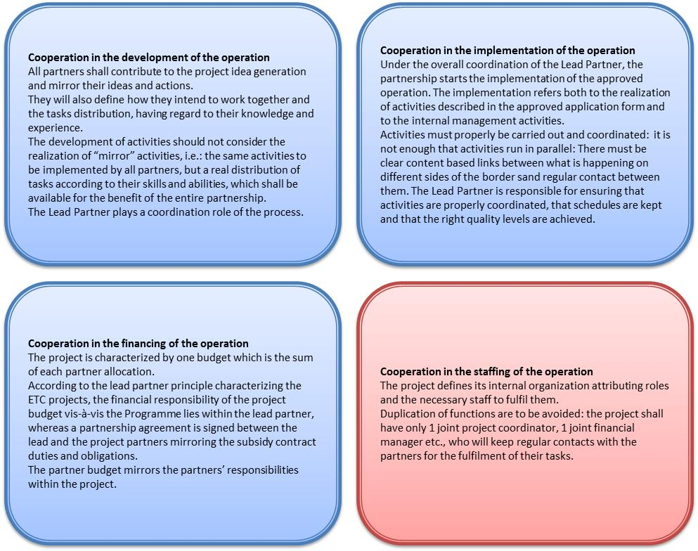

While the presence/absence of the first three dimensions of cooperation is considered as a condition of eligibility of project proposals, their actual shaping in project proposals will be qualitatively assessed, whereas the fourth dimension (joint staffing) will be evaluated as a quality element only.

Location of the operation and related activities
Activities shall be implemented in the ADRION Programme area.

Project duration
Project activities shall start their implementation as from 1 October 2022 at the latest and be finalized by 30 June 2023. No extension shall be envisaged.
Project progress report must be finalized and submitted to the JS/MA no later than 30 September 2023.

Funding method
ADRION contribution is limited to a EU co-financing rate up to 85% of eligible costs for all partners (i.e.: both benefitting from ERDF and IPA II contribution).
The share of expenditure (at least 15%) not covered by ERDF or IPA II funds shall be ensured by national co-financing sources, i.e.:
- Public funding: public co-financing provided by central, regional or local public bodies, obtained either through specific-co-financing schemes established at Partner State level or on an ad hoc basis; public co-financing can also be the contribution directly provided by public or bodies governed by public law involved in the projects;
- Private funding: referred to the amount of own funds provided by private institutions through their involvement, or to the provision of funds from private sources external to the partnerships.

Project budget
The system of financing is a budget-based grant (eligible costs). The grant operates through reimbursement of eligible costs calculated on the basis of a detailed estimated budget, indicating clearly the costs that are eligible for ERDF/IPA II funding. Eligible partners shall ensure stable and sufficient sources of finance to ensure both project implementation and the continuity of the organisation activities throughout the lifespan of the project.
The EU grant may not have the purpose or effect of producing a profit for the beneficiaries (profit is defined as a surplus of receipts over eligible costs incurred by the beneficiaries).
The budget of the project must be drafted following the real cost principle, fully accomplishing the principles of adequacy of costs and sound financial management. The principle of sound financial management builds on the following three principles:
- The principle of economy: it requires that the resources used by the beneficiary in the pursuit of its activities shall be made available in due time, in appropriate quantity and quality and at the best price;
- The principle of efficiency: it concerns the best relationship between resources employed and results achieved;
- The principle of effectiveness: it concerns the attainment of the specific objectives set and the achievement of the intended results.

Use of Euro
The budget must be drawn up in EUR. Applicants not based in the Euro zone are advised to draft their budget share using the exchange rate published on the Official Journal of the EU on the date of the publication of the call for proposals on the ADRION website, keeping in mind that reimbursement - based on actually incurred expenditure - will have to be converted into EUR by the beneficiaries using the monthly accounting exchange rate of the Commission in the month during which such expenditure will be submitted for verification to the national controller.
The exchange rate used for accounting expenditure might be different from the one used for the purpose of drafting the budget. Costs related to fluctuation of foreign exchange rate are not eligible.

Hierarchy of rules on eligibility of expenditure
Three levels of rules apply to the eligibility of expenditure in the framework of all Interreg programmes, including ADRION applicable both to ERDF and IPA II project partners:
- EU Regulations;
- Programme rules:
- ADRION Cooperation Programme;
- Programme Manual and other Programme guidance documents to projects issued by the MA/MC/JS (e.g.: Guidance on communication, Implementation Manual).
Only in case there are no EU level and/or Programme level provisions or they do not offer detailed provisions, national, regional or local legislation and institutional rules apply.
- National rules
- National legislation;
- Local and/or regional legislation;
- Institutional rules and regulations.

National rules cannot prejudice or restrict the rules established at a higher level (EU and programme rules). Stricter programme and national rules may apply only in areas that are not precisely regulated at the EU level or where EU Regulations provide the Partner States with a discretionary power to set such rules.
Whenever different sets of rules apply to ERDF and IPA II beneficiaries, these are expressly indicated in the paragraphs and sub-paragraphs below.

General eligibility requirements
In the following paragraphs a set of financial rules are presented: they are applicable both to ERDF and IPA II partners.

As a general rule, expenditure is eligible for funding if it fulfils all the following general eligibility requirements:
- It has occurred in the eligible period defined by the Programme and within the eligible period related to the duration of the project;
- It refers to costs occurred for the implementation of the project and in accordance with the proposal approved by the MC or its subsequent revisions approved by the Programme implementing bodies, if any;
- It is incurred within the ADRION programme area;
- It is essential for the implementation of the project and it would not be occurred if the project is not carried out;
- It relates to a product or service foreseen in the approved project proposal and that has been delivered and complies with publicity and information requirements;
- It is borne directly by the beneficiary and supported by accounting documents justifying incurred expenses/payments (invoices, pay rolls…) except for costs calculated as flat rates;
- It relates to an activity which has not benefitted from financial support by another public source (double funding);
- It complies with the principle of sound financial management referred to above (efficiency, effectiveness and economy);
- It complies, if required, to the public procurement rules applicable in that Partner State;
- It is registered in the beneficiary’s accounts through a separate accounting system or an adequate accounting code set in place specifically for the project;
- It is not in contradiction with specific Programme rules;
- It has been verified by an authorised national controller.

In accordance with the scope of support of the Regulation (EU) No 1301/2014 the following activities shall not be supported:
- The decommissioning or the construction of nuclear power stations;
- Investment to achieve the reduction of greenhouse gas emissions from activities listed in Annex I to Directive 2003/87/EC;
- The manufacturing, processing and marketing of tobacco and tobacco products;
- Undertakings in difficulty, as defined under Union State aid rules;
- Investment in airport infrastructure unless related to environmental protection or accompanied by investment necessary to mitigate or reduce its negative environmental impact.

Without prejudice to the specific Programme rules defined in the specific paragraph, the following expenditure is considered as not eligible (reference to art. 69 of Regulation (EU) No 1303/2014 and art. 2 of Delegated Regulation (EU) No 481/2014):
- In kind contributions (in the form of provision of works, goods, services, land and real estate for which no cash payment supported by invoices, or documents of equivalent probative value, has been made);
- Interest on debt;
- Purchase of land;
- Recoverable value added tax (VAT), except where it is not recoverable under national VAT legislation;
- Fines, financial penalties and expenditure on legal disputes and litigation;
- Costs for gifts, except those not exceeding EUR 50 per gift where related to promotion, communication, publicity or information;
- Costs related to fluctuation of foreign exchange rate;
- Charges for national financial transactions.

The Programme also considers as not eligible the following expenditure:
- Under travel and accommodation budget line, the cost of taxis is not reimbursed, unless (i) it can be demonstrated that no public transport was available at the time and place needed; or (ii) local transportation is covered with a daily allowance provided for by the internal rules of the concerned partner; or (iii) it is the most convenient transport mean.
- Costs for alcoholic beverages;
- Costs for the creation of a project web site, as ADRION will offer in its web site space for all funded projects in order to guarantee a coordinated visibility, unless duly justified;
- Heavy investments, infrastructures and works, as described by the Directive 2014/24/EU (Annex II).

Additionally, revenues, i.e.: cash in-flows directly paid by users for the goods and/or services provided by the project, such as charges borne directly by users for the use of infrastructure, sale or rent of land or buildings, or payments for services shall reduce the eligible expenditure and consequently the granted amount, with the exception of those operation whose total eligible budget does not exceed EUR 1.000.000. Further information shall be provided in the Implementation Manual.

ATTENTION:
The practice of shared costs shall not be allowed, i.e.: the costs incurred for activities carried out by one partner - or under its responsibility by a sub-contractor – and covered by more than one project partner (the practice of splitting cost items paid by one partner among project partners), even in cases where such activity is for the benefit of the whole project partnership. The budget allocated to a project partner shall fully reflect the activities actually implemented by that partner.

Project budget lines
Project budgets submitted to ADRION must be structured according to the following budget lines only:
- Staff costs;
- Office and administrative expenditure;
- Travel and accommodation costs;
- External expertise and services costs;
- Equipment.

The text below provides a general overview on eligibility of expenditure.
Please note that each expenditure must be detailed indicating the number of unit and unit cost. Lack of this information shall impact the quality assessment of the project proposal.
The information provided herewith is intended to help applicants to properly allocate costs to each budget line during the application phase.

Staff costs
They refer to the gross employment costs of staff employed by the beneficiary institution (lead partner or project partner) for implementing the project. Staff can either be already employed by the beneficiary or contracted specifically for the project.
Staff costs shall be budgeted and reimbursed according to one of two options:
- real costs;
- flat rate of 20% of direct costs other than staff costs..

The choice is made at partner level and cannot be changed during the project implementation.

Staff costs reimbursed based on real costs
Eligible expenditure under this budget line is limited to salary payments and to other costs directly linked to them.
Salary payments related to the activities which the entity would not carry out if the operation concerned was not undertaken, fixed in an employment document (employment contract or appointment decision) or by law, relating to responsibilities specified in the job description of the staff member concerned.
Payments to natural persons working for the beneficiary under a contract other than an employment/work contract may be assimilated to salary payments and such costs are eligible under staff costs only when the following conditions are met:
- The person works under the beneficiary’s instructions and, unless otherwise agreed with the beneficiary, on the beneficiary’s premises;
- The result of the work carried out belongs to the beneficiary;
- The costs are not significantly different from those for personnel performing similar tasks under an employment contract with the beneficiary.
If those conditions are not met, this expenditure must be allocated under budget line External expertise and services costs.
Any other costs directly linked to salary payments incurred and paid by the employer (such as employment taxes and social security including pensions) as covered by Regulation (EC) N 883/2004 provided that they are:
- Fixed in an employment document or by law;
- In accordance with the legislation referred to in the employment document and with standard practices in the country and/or institution where the individual staff member is working;
- Not recoverable by the employer.
Methods for calculating the eligible staff cost vary according to the type of assignment to any individual staff member, as specified below:
- full time: an employee dedicated 100% of his/her working time to the project. The full-time assignment to the project must be included in the employment/work contract or in a specific statement/order issued by the partner structure. No registration of the working time (e.g. time sheets) is required. In such cases the total of the gross employment cost is eligible.
- part-time with a fixed percentage of time worked per month: an employee dedicated to the project by a fixed percentage of his/her working time. This percentage is set out in a document issued by the partner at the beginning of the project, and/or in the same employment/work contract. No registration of the working time (e.g. time sheets) is required. In such cases the fixed percentage of the gross employment cost is eligible.
- part-time with a flexible number of hours worked per month: an employee dedicated to the project by a flexible percentage of his/her working time. In such case the hourly rate shall be calculated according to the following:
hourly rate = latest documented annual gross employment cost/1720 (standard annual working time fixed by Regulation (EU) No 481/2014)
Eligible staff cost shall result by multiplying the hourly rate by the number of hours actually worked on the project by each concerned staff, as resulting from the working time registration system (e.g. time sheets) covering 100% of the actual working time of the individual concerned.
- contracted on an hourly basis: an employee is contracted on an hourly basis and dedicates a certain number of hours to work on the project. The staff costs are calculated on the basis of the hourly rate fixed in the employment/work contract. Data from the working time registration system (e.g. time sheets) providing information on the number of hours spent per month on the project are required. Eligible staff cost shall result by multiplying the hourly rate by the number of hours actually worked on the project by each concerned individual.

Staff costs reimbursed according to the flat rate
Staff costs of any beneficiary choosing this option will be reimbursed for an amount equal to 20% of the sum of costs under all other budget lines, except “staff costs” and “office and administrative expenditure”, without the need of submitting any employment/work contract, any invoice or document having equivalent value nor any proof of payment.

The following table intends to support the choice between staff costs based on real costs and flat rate highlighting pros and cons:

Staff costs reimbursed based on real costs | Staff costs reimbursed based on flat rate  (20% of the direct costs other than staff costs)
Project elaboration
Partnership can decide, in principle, the extent of involvement of their staff; | Ceiling for staff costs;
Project appraisal shall be aimed at verifying whether the staff costs are proportioned with the proposed activities and in accordance with average personnel costs expenditure within the programme area; | Project appraisal shall be aimed at verifying whether the staff costs are in accordance with the proposed activities;
Project implementation
Adequate audit trail of the necessary documentation shall be kept in accordance with the rules set above to get the reimbursement of staff costs; | No accountancy is foreseen (i.e.: no provision of supporting documentation shall be provided to first level controllers);  When reporting staff costs, the distribution of costs between work packages shall reflect the distribution between work packages of the respective direct costs (e.g. costs for external experts and equipment amount to 40% of work package 1 and 60% of work package 2; thus 40% of staff costs shall be allocated to work package 1 and 60% to work package 2);
Staff costs expenditure shall be prior verified by the national controller to be reimbursed; | Staff costs shall not be subject to the verification of national controllers to get reimbursed;
Staff costs can be revised (increased or decreased) during the project implementation. | Flat rate option must be kept along the entire project implementation.
 | Staff costs are automatically generated in the work package if costs under one or more of the following budget lines: travel and accommodation, external experts and services, and equipment are budgeted.

Office and administrative expenditure
It covers operating and administrative expenditure incurred by the beneficiary organisation that support delivery of project activities.
Cost items comprised in the budget line are the following (exhaustive list):
- Office rent;
- Insurance and taxes related to the buildings where the staff is located and to the equipment of the office (e.g. fire, theft insurances);
- Utilities (e.g. electricity, heating, water);
- Office supplies;
- General accounting provided inside the beneficiary organisation;
- Archives;
- Maintenance, cleaning and repairs; o Security;
- IT systems;
- Communication (e.g. telephone, fax, internet, postal services, business cards);
- Bank charges for opening and administering the account or accounts where the implementation of an operation requires a separate account to be opened;
- Charges for transnational financial transactions.

Office and administrative expenditure shall be reimbursed by the Programme according to a flat rate of 10% of eligible staff costs. No detailed budget needs to be planned for this budget line since the expenditure shall be automatically calculated by the online system for the applications submission (e-MS), both in the application phase and when submitting financial progress reports. This expenditure will be reimbursed without the need of submitting any invoice or document having equivalent value or any proof of payment.

Travel and accommodation costs
Expenditure under this budget line refers to the costs incurred by the partner organisation for travels and accommodation of its own staff necessary for the delivery of the project.
The following items are eligible under this budget line:
- Travel costs (e.g. tickets, travel and car insurance, fuel, car mileage, toll, and parking fees);
- Meals costs;
- Accommodation costs;
- Visa costs;
- Daily allowances.

Additionally, COVID-19 tests costs are eligible for project partners’ staff/controllers/experts who are required to travel for the implementation of activities related to the projects/verification of activities and expenditure upon condition that they are not otherwise recoverable, and they are paid or reimbursed by the partner organisation/expert.
In order to get reimbursed, the supporting documents must include a) the proof of payment for the test, b) the proof that the test is compulsorily required for entering in the Partner State or visit the institution and c) the reasons for the travel (e.g.: the programme or agenda of the project event to be attended).

The following principles apply:
- Travel and accommodation costs must clearly link to any project’s activities and be essential for their effective delivery;
- Costs must be definitely borne by the beneficiary organisation (direct payment by a staff member of the partner organisation must be supported by a proof of reimbursement from the employer);
- The principle of sound financial management should guide to the choice of transport and accommodation. In line with the result-oriented policy approach, effectiveness should be the leading principle. In the second instance, cost-efficiency should be ensured, taking into account the entire cost of the mission (travel cost, staff costs related to the travel, etc.). In particular:
  - Beneficiaries must always choose the most economical modes of transport. Exceptions from this principle must be duly justified in each case;
  - Accommodation costs can be accepted if they are in the middle price range, while higher price ranges must be duly justified in each case;
  - Beneficiaries must respect either their ordinary internal rules for travel and accommodation costs (if any), or respect any maximum ceiling for travel and hotel costs established at national level, whichever is stricter;
  - In the absence of internal and/or national rules, maximum ceilings for travel and accommodation established by the Commission and applicable throughout the programme area shall apply. They shall be considered as maximum ceilings. The amounts exceeding such values shall be in any case considered not eligible;
- Any expenditure item defined as travel costs, accommodation costs, costs of meals or visa costs that is already covered by a daily allowance, cannot be accounted for and reimbursed in addition to the daily allowance, i.e.: no double funding is allowed (ref: Article 65.11 of Regulation (EU) No 1303/2013). Beneficiaries shall choose the accounting method (daily allowance or direct costs) which is closer to their ordinary practice and/or internal rules.

Travel and accommodation costs of:
- External experts and service providers including speakers, chairpersons, teachers, etc. shall be reimbursed under the external expertise and services budget line;
- Associated partners can only be claimed under the external expertise and services budget line. They must be incurred and paid by the LP/PP which have reported in the AF their willingness in supporting these costs.

ATTENTION:
In case of approval of project proposals, costs for travel and accommodation for attending programme or national authorities’ meetings and events shall be considered as eligible: it is advisable that some additional budget is allocated to attend these events.

External expertise and services costs
This budget line covers costs paid by beneficiaries to external experts and service providers on the basis of contracts or written agreements and against invoices or requests for reimbursement.

Sub-contracting between beneficiaries inside the same project partnership is not allowed.

Beneficiaries can sub-contract to external experts and service providers only tasks or activities which are essential for the implementation of the project.
When awarding external expertise and service contracts all project partners irrespective their legal status must ensure that EU and national rules on public procurement are respected, in accordance with the amount of the contract. All contracts must comply with the basic principles of transparency, non-discrimination and equal treatment as defined in the EC Treaty and the Commission Interpretative Communication on the Community law applicable to contract awards below the EU thresholds.
In particular:
EU beneficiaries shall respect EU Directives and their respective national legislation on public procurement, depending on the amount concerned.
Furthermore, whenever public bodies or bodies governed by public law have defined internal rules for the purchase of goods and service below the minimum thresholds set by national laws, such internal rules must be respected.
IPA II beneficiaries shall follow the provisions of the Practical Guide on Contract Procedures for European Union External Actions (PRAG) in line with the Financing Agreement concluded between the relevant Partner State, the European Commission and the MA.
Expenditure of external expertise and service costs shall be limited to the following:
- Studies or surveys (e.g. evaluations, strategies, concept notes, design plans, handbooks);
- Training (e.g. venue and trainers);
- Translations;
- IT systems, modifications and updates (e.g. setting-up and/or update of a project IT system);
- Promotion, communication, publicity or information;
- Financial management;
- Services related to the organisation and implementation of events or meetings (including rent, catering or interpretation);
- Participation in events (e.g. registration fees);
- Legal consultancy and notarial services, technical and financial expertise, other consultancy and accountancy services;
- Intellectual property rights;
- Verification and validation of expenditure carried out by authorized national controllers;
- Travel and accommodation for external experts, speakers, chairpersons of meetings and service providers;
- Other specific expertise and services needed for the project.

External expertise and services have to be duly specified in the full AF by describing at least the nature and quantity of the expertise/service, the link to the relevant deliverable or output as listed in the work plan and the related budget of the concerned project partner.

Costs referring to project-related tasks sub-contracted by the beneficiary to in-house bodies are eligible under external expertise and service budget line on condition that the following is met:
- Costs incurred by the in-house body are charged on a real cost basis without any profit margin;
- The sub-contracting to the in-house body of project related tasks complies with national and institutional public procurement provisions in force.

ATTENTION:
Bearing the short duration of the project, the partnership shall be aware of the necessity of well-organised public procurement procedures to select external experts for the timely implementation of tasks foreseen.

Further specific national eligibility rules are reported in the following page of ADRION web site:
https://www.adrioninterreg.eu/index.php/library/guidelines-for-partners/
whereas information on verification of expenditure and appointed institutions is available in:
https://www.adrioninterreg.eu/index.php/contacts/national-contact-points/

Equipment expenditure
This budget line covers costs related to equipment purchased, rented or leased by a beneficiary which is essential for the implementation of the project and for carrying out project activities.

Cost of equipment is only eligible if foreseen in the approved AF. During project implementation, purchase of any equipment not explicitly mentioned in the AF will have to be subject to prior approval by the MA/JS.

Eligible cost items under this budget line are:
- Office equipment;
- IT hardware and software;
- Furniture and fittings; o Laboratory equipment;
- Machines and instruments,
- Tools or devices;
- Vehicles;
- Other specific equipment needed for the project.
Computers, office furniture, printers, cameras, etc. are eligible upon condition that it is for the exclusive use for the project and it can be demonstrated. When the exclusive use for project purposes and activities cannot be demonstrated, such costs are deemed to be covered under the office and administration budget line.
Equipment for general office use shall be reimbursed by the Programme, based on the depreciation rates in compliance with the national rules and calculated only for the time period between the purchase of the equipment and the end of the project.
Costs of office equipment already in possession of the beneficiary organisation and used to carry out project activities are not eligible under this budget line, as such costs are already covered under the budget line office and administration.

The full cost of equipment is only eligible when the following conditions are satisfied:
- Equipment item is exclusively used for the project implementation; and
- The depreciation period is shorter than the time lap between the purchase of the equipment and the end of the project; or
- Equipment item is not depreciable (e.g. low value asset) according to the national legislation of the concerned partner.

All the equipment items must be clearly indicated in the AF. Projects are required to describe the nature, quantity and cost of each equipment item foreseen to be purchased, as well as indicate the link with the deliverables and outputs foreseen in the work plan. In case of depreciation, it should be also illustrated how the costs for the project were calculated.
The selection of the suppliers for the purchasing, rental and/or leasing of any equipment item shall comply with the relevant EU and national public procurement law in force, and in case of the IPA partners, with the PRAG rules.
Equipment cannot be sold (i.e.: change of owner) for at least 5 years after the project end date.

3. PROCEDURE FOR SUBMISSION AND SELECTION OF OPERATIONS

Publication
The announcement of the fifth extraordinary call for proposals and the related Application Package is available on the web site of the ADRION Programme.
The Application Package contains:
- The fifth extraordinary call for proposals announcement;
- The present manual;
- ADRION Cooperation Programme;
- Declarations’ template;
- The off-line Application Form (for information purposes);
- eMS manual (for information purposes).

In case of project approval by the MC, financing partners shall be asked to provide Declarations on their financial commitment, whereas associated partners shall be asked for Declarations on their engagement.
Declarations signed by the legal representative/delegated person of the Lead Applicant must be accompanied by a document attesting that he/she holds the power of signature and representation and by a valid identity document (e.g. identity card, passport).

Submission of project proposals
Applications must be submitted through the online application system (e-MS) available on the programme web site www. interregadrion.eu (https://ems.regione.emilia-romagna.it/).
Lead applicants need to register on the e-MS system and provide a set of credentials (username and password) to create and submit the AF on behalf of the entire partnership.
Interested applicants are invited to access the online application system for the purpose of creating credentials (ID and Password) as early as possible. Credentials must refer to the legal representative/delegated/ person: no general email address (e.g: info@xxxxx. Xxx) shall be accepted.

Applications must be drawn up in English, using the online form specifically designed for this purpose, and be submitted by the deadline (date and Bologna time) reported in the call announcement of the call for proposals.
No other method of submission of an application will be accepted. Applications submitted in any other way will be automatically rejected. No exceptions will be made.
The project proposal shall:
- Be submitted by the Lead Applicant on behalf of the entire partnership;
- Be submitted using the credentials of the Lead Applicant.

Lead Applicants shall be ensured of having officially submitted their electronic application form through an automatic e-mail acknowledging receipt of their submission. The Lead Applicant shall regularly inform the other project partners on the communications received by the MA/JS.

Interested potential applicants are requested to submit their project proposal through a one-step application procedure, i.e.: the submission of the project proposal in its entirety.
Project acronym must be written in capital letters and numbers only.
The submission process is paperless.

The Fifth Extraordinary call for proposals will be open from 7 June 2022 (h: 10:00) to 08 July 2022 (h: 15:00) – CEST time and will follow a single step procedure, i.e. full Application Form and requested.

Application Form
The project proposals shall be sent via eMS through the filling-in of the pre-defined application form template; off-line application form is provided in the application package for information purpose only.
The Application Form (AF) is structured according to the following:
- Project summary;
- Project partners;
- Project description;
- Work plan, structured according to work packages;
- Partner budget;
- Project budget overview;
For most of the sections, a maximum number of characters is fixed by e-MS.

ATTENTION:
The on-line application form is characterised by the presence of blocks and/or warnings in most of its parts to force the applicants to ensure its duly filling-in. If the missing information highlighted by the block is not provided, the system will not allow the submission of the proposal.

Project summary
The project summary provides an overview of the project. Projects are required to provide a clear description of the common challenge of the Programme area that the project intends to tackle; the overall objective, the targeted topic(s) of the call; the main outputs that will be produced, the expected change foreseen to be realized in respect to the current situation, the chosen approach and the transnational dimension. In the project summary reference to topic(s) must be provided.

The summary will be published on project website in case the project is financed: it must be, therefore carefully written and effective.

Project partners
Partnership is the cornerstone in which lies the success of the project proposal. The quality of a project depends at a high extent from the composition of the project partnership.
Projects shall apply a result-oriented approach even in the involvement of the required actors in the partnership.
Data at Lead Applicant and project partner level are requested also with regard to the developed experiences and thematic competences relevant for the project experience and at project management level.
Information on the selected partnership is to be provided with regard to the profiles of the involved organizations; the specific competences in relation to the Adriatic-Ionian area; the distribution of roles among the project partners.
In addition, in case associated partners are envisaged, description of their contribution to the project is expected.

Only legal entities eligible for funding in accordance with the call requirements and listed in the AF as project partners may report their costs.

Project description
This part of the AF is divided in different sections: C.1 Project relevance, C.2 Project focus, C.3 Project context, C.4 Horizontal principles.

C.1 Project relevance
Cooperation criteria: the project must explain the way and the level of cooperation among partners in the framework of a project proposal according to the following compulsorily cooperation criteria: joint development, joint implementation, joint financing. The other cooperation criterion joint staffing is not obligatory.

C.2 Project focus
Project proposals must clearly define their intervention logic from the beginning, setting their objectives and expected results and indicating clearly the change that they would like to bring in respect of the initial situation. The project intervention logic can be visualized as follows:

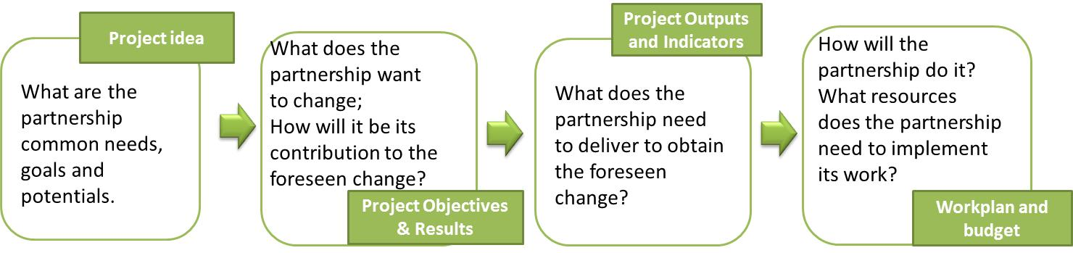

The project intervention logic must be coherent and show its contribution to the chosen Priority Axis intervention logic and its achievements:
- The project specific objective describes the specific and immediate objectives of the project that can be realistically achieved within the project life-time, through the deployment of the project outputs. The project proposal can include up to three project specific objectives);
- The project outputs contribute to the achievement of Programme outputs, ideally directly, so they can be aggregated on Programme level. Information on durability and transferability of project outputs must be provided in the devoted sections.

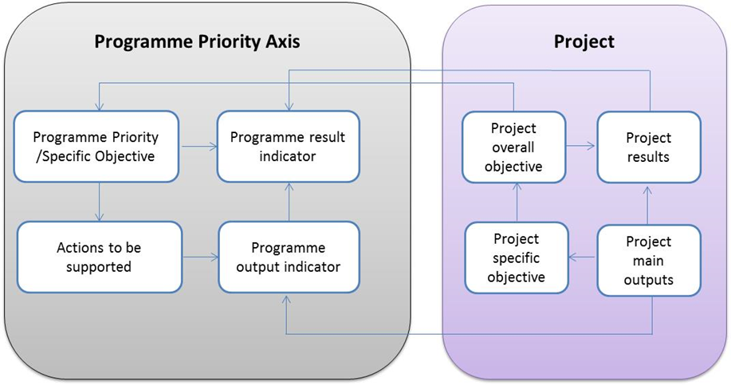

Projects not clearly addressing the identified topics will not be supported by the ADRION Programme.

Output indicators
In accordance with the Priority Axis where the chosen topic is framed, both listed output indicators must be selected:
Priority Axis 1 (topic: blue economy and social innovation):
OI_1b.1_1 Number of supported transnational cooperation networks and clusters (WPT1);
OI_1b.1_2 Number of strategies and action plans developed by transnational innovation networks and clusters (WPT2);

Priority Axis 2 – SO 2.2 (topic: circular economy and renewable energy):
OI_6d.1_1 Number of supported transnational cooperation networks (WPT1);
OI_6d.1_2 Number of strategies and action plans developed in the field of environmental protection (WPT2);

where:

Networks must be conceived as innovative transnational ones. The aim of the networks under this specific call is to set in place a network of universities/faculties, research institutions and business partners working together on skills’ enhancement and capacity building in the thematic domain selected.
The network structure must be understood as the systematic establishment and management of internal and external links (communication, interaction, and co-ordination) between people, teams or organizations with a long-term perspective in order to improve performance.

ATTENTION:
The constitution of the network as the final project output must be formalized through a structured document containing at least three of the following elements:
- Overall goal of the network, highlighting the link with the leading goal of the funded project;
- Reference to the used tools (if any) and activities developed by the project to be used and/or further implemented by the network;
- Network governance;
- Network membership: characteristics, duties and obligations (e.g.: continuing the implementation and development of what started within the project, further implementation of activities based on what achieved by the project;
- Methods and strategy to widen the network;
- Openness to additional members: conditions and requirements;
- Network duration.

The development of strategy and/or action plan must be addressed to the selected topic envisaged by the 5th Extraordinary call.
Strategy: must be understood as an integrated framework endorsed by all the project partners to address the common challenge (i.e. implementation of a joint Master Programme), which thereby benefit from strengthened cooperation contributing to the identified achievements.
Action Plan: must be understood as a strategic document that precisely defines how the master programme developed by the partnership will be implemented in each participating region/country involved. The strategic document must include all the concrete actions/measures necessary to be undertaken to reach the envisaged goal and related timeline, based on an integrated approach, and ensuring the logic sequence of actions linked to the goal, including the financial resources for its successful implementation.

ATTENTION:
The constitution of the strategy and/or action plan as the final project output must be formalized through a structured document containing at least three of the following elements:
The conceiving of the strategy as final project output must be formalised through a structured document containing at least three of the following elements:
- Strategy vision in relation to the initial contribution provided by the project in relation to the affected geographical area through the involvement of partners, how it is intended to review it in relation to endogenous and exogenous situation to ensure its alignment with the original goal;
- A mission statement according to which what the project is currently doing in relation to the said goal, to whom is addressed and how;
- The state of play according to which your strategy is based on: it can be, e.g.: the result of one of the outcomes of the funded project or an ad hoc swot analysis, or any other analysis able to support the strategy vision and related action plan;
- Identification and definition of long-term goals that the strategy intends to achieve; they are related to the duration of the strategy (from 3 to 5 years);
- Strategy duration: it is expected that the strategy lasts from at least 3 to 5 years in order to ensure time enough for achieving the set goals. Set goals should be further disentangled according to sub-year/shorter goals;
- Goals definition: the SMART approach (Specific, Measurable, Achievable, Realistic, and Time-based) is to be adopted;
- Must be publicly available.

The action plan must contain at least three of the following elements:
- Realistic actions in relation to each objective to be reached and the related timeline envisaged;
- Includes an integrated approach ensuring the logic sequence of actions and link to the planned strategic goals;
- Includes all necessary elements to ensure the achievement of the planned strategic goals;
- Resources to ensure its implementation;
- Must be publicly available and make public the reached achievements.

The document attesting the formal constitution of the strategy (i.e. signed expression of interest and/or any other form attesting it) and/or the action plan must be signed by all institutions; a copy must be sent to MA/JS with the last project progress report at the latest.

The outputs being part of the project intervention logic are defined within the respective implementing work packages.

C.3 Project context
Information on the synergies with other academic/ scientific/ entrepreneurial initiatives the project intends to make use of and how the project make use of building available knowledge is required.

C.4 Horizontal principles
The project proposal is required to indicate how it will contribute to the following compulsory horizontal principles by providing justification on how they will be achieved:
- Sustainable development (environment);
- Equality between men and women;
- Equal opportunity and non-discrimination.
Failing in indicating the relevant horizontal principles (e.g.: marking as positive the contribution to ALL principles without providing adequate justifications) will lead to the rejection of the project proposal. In case of a negative contribution to a horizontal principle, an adequate justification or adequate mitigation measures have to be provided, otherwise it will be considered as ineligible.

Work plan
Project activities within the frame of the ADRION Programme shall be organised around work packages, i.e.: a group of related project activities necessary to produce project deliverables and outputs. The organisation of the activities in work packages ensures a shared knowledge about the project’s structure and objectives among all Project Partners; additionally, it increases the capacities of the ADRION MA/JS to follow up the implementation of the expected activities and facilitates the procedures for reporting and accounting of expenditure.
Each work package (WP), structured in activities, shall provide information on the Project Partners involved, the description of the related deliverables and expected outputs, and the related budget.
The following figure illustrates the relationship between project activities, deliverables and outputs within a WP.
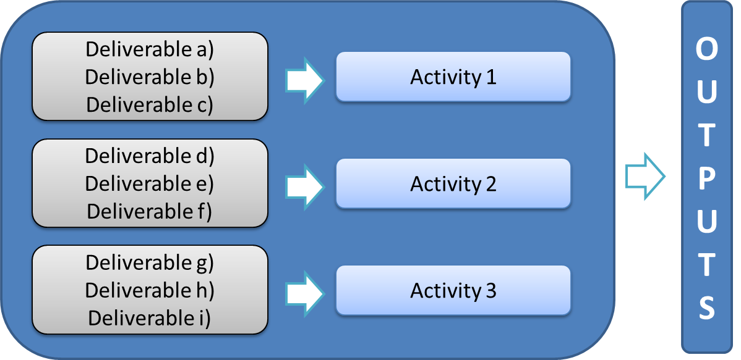

More specifically, each WP is composed of defined activities and related deliverables and expected outputs:
- An activity is a specific task performed for which resources are used; the proposed activities shall have a logical sequence and implemented for the direct benefit of the area /Project Partners involved in the project. For each activity it must be indicated the starting and ending date, as well as the related cost. The sum of the indicative budgets of single activities foreseen within the WP must be equal to the WP budget. The activities of the Implementing WPs (please refer to the following paragraph) must lead to the deployment of one or more project outputs;
- A deliverable is a tangible or intangible object produced as a side-product of the project that contributes to the achievement of a project output. Each activity can include one or more deliverables (e.g. feasibility study; swot analysis; sectoral analysis etc.). Project deliverables like minutes of the meetings with the stakeholders, working groups etc. cannot be listed as separate deliverables but must be aggregated into one deliverable (e.g. report on the involvement of the stakeholders). More than one deliverable can be necessary to produce one output and they must explicitly refer to the output to be produced in the work plan;
- An output is what has actually been produced as a result of the funding awarded to the project (i.e.: strategy/action plan, networks, tools and methodologies, pilot action and joint management systems and cooperation agreements). It shall be captured by a Programme output indicator and contribute to the achievement of project result(s). Each implementing WP must foresee at least one project output. The outputs must be developed and implemented within the project lifetime.

The partnership shall structure its project proposal according to 3 WPs:
- Project management and coordination of activities, including communication activities (WPM);
- Networking and implementation of Education and Training Programme concept (WPT1);
- Definition of a joint master degree on the thematic domain selected (WPT2).

Project management and coordination of activities
This WP includes the activities aim at ensuring a sound management and coordination of the project: both the overall project management and all aspects linked to the financial management must be described. It shall also provide proof on how the work between the partners involved by building a strong collaborative relationship is organized and distributed. The coordination and management activities shall result in the successful implementation of the project as well as in the production and submission of the administrative documents for accounting of expenditure and reporting on the activities implemented.
The partnership must set in place adequate project coordination structure(s) (e.g.: steering committee, steering group, coordination board etc.) ensuring that all project partners are equally represented, including the Associated Partners. The partnership may decide to involve in the coordination structure also representatives of institutions not directly involved in the project which can contribute to its implementation or spreading its outcomes.
The partnership must define the structure, responsibilities, and procedures for the day-to-day management and coordination (including whether it is foreseen the externalization of the management), internal communication and reporting.
The work package shall also include the activities related to the project closure that have to be finalized within 3 months after the official end date of the project: they include the submission of the required final administrative documents - the final progress report – the final payment claim and the eventual reconciliation with the initial granted amount.

WPM shall also provide communication specific and measurable objectives (i.e.: proposing of “raising awareness” or to “spread results” without providing to whom and how is not enough), as well as the addressed target groups.
The following elements shall be considered:
  - Identification and definition of the communication objective;
  - Integration with the overall project strategy and project specific objectives;
  - Quantification of the communication products (target values), detailed planning of their realization and estimated budget;
In order to ensure a shared and consistent brand identity of the ADRION Programme, a common one has been developed by ADRION. Each approved operation shall be required to use an integrated project logo (template provided by the Programme).
Additionally, in order to ensure accessibility, durability and consistency of the information, each ADRION project will have its own dedicated page on the Programme website, showcasing the project to a wide audience. The project page(s) will include a pre-filled information field completed by the Programme, and dynamic information to be filled-in by projects.

Project implementation
The project implementation is the heart of the project and describes what the partnership intends to implement to reach the foreseen goals.
The following WPs are compulsory:
WPT1 – Networking and implementation of Education and Training Programme concept
These minimum elements must be present and adequately described in a detailed way:
- Setting in place a network of universities/faculties, research institutions and business partners working together on skills’ enhancement and capacity building in the thematic domain selected.
- Organisation and implementation of training courses, summer schools or any other educational form either individually or jointly to prepare and promote the future master on the thematic domain selected. These activities must involve at least 25 persons per country.
- Exchange of experience, best practices, staff exchange and mutual learning processes for the definition of the joint master and curricula, as well as its functioning.
For their implementation the following elements can be considered:
  - different settings - on-line/classroom sessions, boot camps, work-based sessions, summer schools; study visits;
  - formats - part-time, full-time, formal education and training, open learning;
  - methods - webinars/online events and workshops, peer-to-peer learning, exchange of experience, including short-term staff exchange between partners.
The work package must include, per each involved partner, at least 1 representative responsible for the development of each of the sub-points above.
Certificate of attendance for training courses/summer schools etc. must be a compulsory deliverable under WPT1.

WPT2 – Definition of a joint master degree on the thematic domain selected
These minimum elements must be present and adequately described in a detailed way:
- Definition of a joint master to be realized by the universities network. The joint master must be conceived in a way that participants shall have the chance of attending a specific university for some courses/modules (at least 50% of the total master duration) and another participating university for other courses/modules and/or professors shall be hosted by other universities. The joint master must foresee the students’ mobility in at least two different universities and in one business partner/research institution.
- Joint master must include agreed language policy and a mechanism for recognition of study periods within the partnership. Additionally, the partnership must develop joint students’ admission requirements and selection procedures. Students’ support services must also be envisaged (e.g. support in obtaining visa).
- Definition of the university path and of the mobility scheme, in cooperation with business partner(s)/research institution(s), addressed to the identified target groups. The partnership must describe how the cooperation with business partner(s) or research institution(s) is organised and for which purpose.

The joint master must contain both technical knowledge and hands-on experience.
The backbone of the joint master must be the scientific and technical basis covering all the aspects of the topic selected. The joint master must educate the participants with up-to-date technical skills and state-of-the-art of technological knowledge.
The joint master programme must be focused on the main research areas addressed to the current and future industrial, technological, and social challenges (e.g.: industrial valorisation of waste; environmental pollution reduction; natural resources saving and efficiency, social entrepreneurship; innovative social businesses, models, tools, and techniques bringing the social change and answering to the complex social situation of the area etc.). Study tours or on-site visits at the premises of e.g.: innovative companies and industrial sites, research institutions, as well as learning by doing course modules based on real-life problems must be envisaged.
The joint master must also foresee an internship of up to 6 months at the business partner(s) (e.g.: SME) and/or research institution(s) and the elaboration of a master thesis in collaboration with the business partner(s) and/or research institution(s).
The internship will give the opportunity to the students to gain extensive real-life experience in research or industry.
The joint master degree must be awarded by all the universities involved in the mobility scheme (minimum requirement: at least two).
If this is not possible due to their legislation in force, a multiple degree recognised by all university partners can also be accepted.
Whereas the Certificate of attendance for training courses/summer schools etc must be awarded by the university performing the educational/training concept and by all the universities involved if performed jointly.
All educational deliverables must be clearly defined in terms of curricula development, tasks distribution among partners and necessary resources for their successful implementation.

Non-compulsory work packages
Preparation costs
The approved projects which have signed the Subsidy Contract and the Partnership Agreement with the MA are entitled to receive reimbursement of their preparation costs in the form of a lump-sum of maximum EUR 11.800,- of total eligible expenditure per project of the foreseen AF. That means that they will be reimbursed with no need to present invoices or other supporting documents for the incurred costs.
The reimbursement of preparation costs will follow the principles specified hereunder:
- Any preparatory costs incurred by the partnership must be indicated in the AF, under the specific budget line(s) concerned and included under the budget of the concerned partners;
- The formal request for reimbursement of the preparatory costs can be submitted by the Lead Partner only after the signature of the Subsidy Contract and Partnership Agreement;
- The amount of actual reimbursement will result from applying the co-financing rate applicable (up to 85%) to the respective preparatory cost budget of the concerned partners (e.g. to which the lump sum is allocated), as indicated in the AF;
- The lump sum will be reimbursed to the Lead Partner; it will be its duty to transfer to its partners their respective shares, according to the approved preparatory costs;
- Any costs incurred by the projects between the date of submission of the AF and the date of signature of the subsidy contracts (between the end of the preparation period and the start of the implementation period) for negotiating/satisfying specific conditions for approval cannot be claimed;
- In case a project is not implemented or even started, the MA will recover the amounts of EU funds already reimbursed based on this lump-sum.

Under the WP Preparation costs all budget lines but equipment can be budgeted.

Partner budget
Project financial table is partly pre-filled by the system with data on project partners.
The starting point for drafting the project budget is the section “partner budget”. The budget of each partner is broken down per budget line, work package and reporting period.

Only one project report is envisaged. Its start date shall be as from the project start of activities.
Project end date shall be 30 June 2023 at the latest.
The deadline for the submission of the project progress report shall be 30 September 2023.

ATTENTION:
Please note that modifications of project start and end dates and periods after the insertion of budget data might have an impact on “Partner budget”. Financial data are inserted per period and are lost when deleting a period.
When entering data, please remember to regularly save entered data.

Steps to be undertaken when defining the budget are the following:
  - Enter the budget of the selected partner;
  - Select whether the concerned partner organisation will charge staff costs to the project according to real costs or a flat rate option. Please note that, after the submission of the AF, the partner will not have the possibility to change this choice anymore;
  - Three tables will be displayed on the screen: the first table displaying budget lines and work packages; the second table displaying budget lines and reporting periods; the third table displaying reporting periods and work packages.
Applicant enters the partner budget in the first table “Budget lines and work packages”. The other two tables will be automatically updated once budget data are entered.
For budget line 1 “Staff costs”: unitary costs and number of units must be included for work package and reporting period. The applicant has to specify the type of staff (e.g.: “Part time with a flexible number of hours”). In the column Comments a short description must be added (e.g.: “Finance officer, Senior staff, in charge for finance report, and the related amount).
Partner institutions choosing the flat rate option for the reimbursement of staff costs cannot enter any information, since the budget is automatically calculated.
For budget line 2 “Office and administrative expenditure”: data cannot be entered since the budget is automatically calculated.
For budget line 3 “Travel and accommodation costs”: unitary costs and number of units must be included for the entire work package and reporting period, including a short description explaining the purpose of the travel and, where possible, the destination.
For budget line 4 “External expertise and services costs” and budget line 5 “Equipment expenditure”: a breakdown of the budget line at the level of each item included under this budget line is to be created. The applicant has to specify each concerned item to be purchased (please ensure consistency with the same data reported in other sections of the AF): costs, nature and quantity. Information must be added on the rate and calculation of the depreciation period. The budget allocated to the single cost item has then to be entered at the corresponding work package and reporting period.

In case the project proposal is expected to generate revenues, they must be included in the relevant category available in the budget table.

Once the partner budget is inserted, information on national co-financing type and source is to be included under “Partner budget”. Two tables are available: the former presents the overall Programme co-financing and the partner contribution according to the applicable co-financing rate (automatically filled-in by the system), the latter refers to the partner co-financing sources and is to be filled in by the applicant. In the table on partner co-financing sources, the system by default includes the partner’s own resources as first co-financing source, in line with information on legal status. To add other co-financing sources, the applicant has to provide information on the source of co-financing, the legal status (i.e. private, public, automatic public) and the amount. Please carefully check the consistency of the total amount of co-financing manually entered in the second table with the amount automatically calculated in the first table.
Automatic public co-financing refers to specific co-financing schemes set up by some Partner States.

Project budget overview
The overall project budget coming from data entered at partner level can be seen in sections Project breakdown budget and in “Project budget” of the AF. Each budget table can also be exported as an Excel file.

Assessment of the applications
The assessment of the application is coordinated by the MA/JS which will supervise a pool of experts. The National Contact Points shall support with the direct verification of some requirements of the project partners.
In order to ensure equal, fair and transparent approach, the project proposals are assessed according to a set of criteria and sub-criteria previously elaborated by the Programme, approved by the MC and specified in the following paragraphs. The results of the assessment are reported in a project assessment grid to be prepared for the supporting the MC decision.
The MC is in charge of the final decision on the selection of the operations for funding.
Only the information provided in the application form shall be subject to assessment.

Admissibility and eligibility check
The admissibility and eligibility checks are aimed at ensuring the minimum project requirements.
Only those applications which successfully pass these checks are allowed to progress in the assessment process. The list of admissibility and eligibility checks to be fulfilled is provided below.
The verification of the presence of all the requirements is performed by the JS with the support of the NCPs. Applicants may be contacted by their NCPs for the provision of specific documentation.
Results of the admissibility/eligibility check shall be communicated to the MC for endorsement.

Admissibility, eligibility, and quality criteria
The following admissibility criteria will be automatically checked by the online system (eMS):
- Only applications received via eMS and submitted within the set deadline will be taken into account;
- Completeness of the submitted Application Form.
No further checks are envisaged.

The following eligibility criteria related to:
- Minimum number of partners and their location;
- Location of the lead partner;
- Maximum duration of the project;
- Compulsory cooperation according to the following: joint development, joint implementation and joint financing;
- Selection of one of the pre-identified priority axes and specific objectives;
- Maximum EU budget;
will be automatically checked by eMS (i.e.: only applications that fulfil these requirements can be submitted).

The following additional criteria shall be checked by JS/NCPs:
Criterion | Eligibility questions
The lead applicant is eligible | Is the lead applicant a public body/body governed by public law university/faculty?  Is it located (operational and legal seat) in the Adriatic-Ionian programme area?
Project financing partners are eligible | Do project partners belong to one of the categories set forth in the present programme Manual?  Are they public body/body governed by public law/private body?  Are they located (operational and legal seat) in the Adriatic-Ionian programme area?
Project partnership | Are at least 5 project partners universities/faculties and is at least 1 business partner and/or a research institution included in the project partnership?  Is the institution proposing itself as lead applicant involved in only one project proposal with the same role?  Has the limit of participation of the same university/faculty as project partner been respected (up to three)?  (In case the same university/faculty applies more than three times as project partner, the principle of "first arrived, first served" shall apply).

All Lead Applicants shall be informed about the results of the project proposal assessment, including its admissibility and eligibility via eMS.

Quality assessment
Only those applications which have passed the admissibility and eligibility checks shall be assessed from a quality point of view.
The quality assessment shall be performed by external experts, coordinated by the JS, according to a list of criteria reported below.
Criterion | Quality question
Partnership | Are the partners experienced in the selected topic?  Is the partnership relevant and effective to reach the envisaged goals?  Is the lead applicant experienced in complex project management and capable of coordinating the transnational partnership? Can it ensure an efficient management support?
Management (including Communication) | How well the foreseen management structure (e.g.: project steering committee, project coordination unit) is proportionate to the partnership, project size and needs and how well does it allow partners’ involvement in decision-making?  Does project management include regular contacts between project partners and ensures transfer of expertise across the partnership?  To which extent are the proposed information and dissemination activities able to achieve visibility among relevant target groups and stakeholders (e.g.: the relevant target groups are clearly defined and cover the entire project area? The general approach towards each group is described through relevant channels, tailored activities, etc?)
Work plan | Are the work plan, timing of activities and deliverables realistic, consistent, durable and transferable?  How well does the project make use of the available knowledge and build on existing results and practices in the topic addressed?  How well does the project contribute to the horizontal principles?  Do WPT1 and WPT2 comply with the requirements set forth in the call announcement?  Shall the envisaged educational activities deliver the relevant certificate of attendance/degree?  Are tasks and roles of each partner clearly described?  How well is the distribution of tasks among partners appropriate?
Budget | Are planned resources reasonable and sufficient to ensure project implementation?  Are the partners’ budgets in accordance with their role in the project?  Is the project budget clear, realistic and justified (ref. to budget lines and work packages)?

The overall project score will result from the total attributed scores according to the following.

5 | Excellent – the section of the application analysed in accordance with the requirement of the criterion is of excellent quality and provides clear and coherent information
4 | Good– the section of the application analysed in accordance with the requirement of the criterion is clear and contain minor shortcomings
3 | Adequate -the section of the application analysed in accordance with the requirement of the criterion is sufficiently clear and requires further clarification from the applicant
2 | Sufficient - the section of the application analysed in accordance with the requirement of the criterion is of low quality
1 | Poor- the section of the application analysed in accordance with the requirement of the criterion does not meet the requirement/the information is not present

The overall project score will result from the total attributed scores.

Anti-fraud check
The anti-fraud check shall consist of the verification of previous fraudulent behaviours or other fraudulent practices by the partners involved in the project proposal.
The anti-fraud check shall take place only on those applications which successfully passed all the previous checks described in the appraisal process.
The check will be done by MA/ relevant national authorities with the support of the NCPs and with the use of tools and practices currently in use (e.g.: cross checks with the national authorities administering other funds, knowledge of previous fraudulent applications and other fraudulent practice; use of EU databases).
In case the fraudulent behaviour/practice affects:
- the Lead Applicant: the AF shall be rejected;
- a Project Partner, it will be excluded from the project proposal.

ATTENTION:
Please note that in case the project proposal, following the exclusion of one or more project partners, does not meet the eligibility requirements set forth with regard to the project partnership, the project proposal shall be rejected.

Exclusion of presence of double funding
In accordance with Art. 181.4.b) of Regulation (EU, Euratom) No 2018/1046 (Financing Regulation), and with what reported in the self-declaration signed by each applicant with regard to the exclusion from subsidy (Lead applicant and project partners’ declarations), MA/JS perform checks in order to exclude that the activities to be funded have been already granted to the same potential beneficiaries by Interreg Danube and MED programmes.
Checks are performed through the analysis of approved applications dealing with similar topics implemented by the same institutions involved in project proposals recommended for funding.
Check shall take place only on those applications which successfully passed all the previous checks described in the appraisal process.
In case the presence of double-funding is confirmed, identified activities are considered as not eligible; this may imply the rejection of the project proposal.

Finalization of the project assessment grid
The results of the assessment shall be reported in a project assessment grid to be submitted to the MC in charge of the funding decision. The assessed projects shall also be included in a ranking list according to the chosen Priority Axis and received overall final score.

Decision making and communication to the Lead Applicants
The decision for funding is adopted by the MC by consensus.
A project proposal can be:
- Approved: the proposal is considered ready to start, fulfilling the requested quality level and responding to the selection criteria;
- Approved under conditions: the proposal is considered approved provided that the Lead Partner and/or the project partners satisfy specific conditions within a given deadline;
- Rejected: the proposal is considered not matching a certain readiness, quality level and not responding to the selection criteria.
If a project proposal is funded under conditions, the latter are approved by the MC too; conditions may also foresee a lower budget than the amount requested by the partnership.

All Lead applicants of the assessed projects shall be notified by MA/JS in written form about the MC decision via eMS. The Lead Applicant shall immediately inform all the partners accordingly.
Under no circumstances the amount awarded may exceed the amount requested;
The approved operations shall be asked to deliver the MA/JS partners’ declarations via eMS.

Contractual provisions

Principle of non-cumulative award (double funding)
Applicants must declare to inform the MA/JS on any EU or other public funding source - be international, national, regional or local - received after the submission of the project proposal.
If during project implementation evidence emerges that an activity/item of expenditure which is being co-financed by ERDF/IPA II funds of the ADRION Programme, is at the same time being co-financed by any other public fund, the MA may:
- Impose the modification of the concerned activities and/or exclude from the eligible expenditure the item which would be double-financed;
- Withdraw from the subsidy contract and demand the repayment of amounts already disbursed.

Subsidy Contract
In the event a subsidy is awarded, MA/JS shall proceed with the verification of the existence of the signatory person and its power of signature.
A Subsidy Contract, drawn up in Euro and detailing the conditions and percentage of funding, will be sent to the Lead Partner on behalf of the entire partnership.
The text of the subsidy contract is approved by the MC and cannot be modified.
The Subsidy Contract will be signed by the MA and by the Lead Partner.
The Subsidy Contract is requested to be returned digitally signed or in paper version: if the digital signature system is not available, the Lead Partner sends back the MA two copies of it in hard copy, dated, initialled in each page and signed in full in the last one. The MA signs last and sends back a countersigned copy.

Exclusion from subsidy
Applicants will not be granted financial assistance if, in the course of the grant award procedure, they:
- Are subject to a conflict of interests;
- Are guilty of misrepresentation in supplying the information required by the Programme as a condition of participation in the grant award procedure or fail to supply this information;
- Find themselves in one of the situations of exclusion, referred to in the previous paragraph.

ATTENTION:
False declarations detected after the approval of the project will imply the exclusion of the concerned project partner from the partnership and may bring to the ineligibility of the proposal.; if false declarations are provided by the Lead Partner, the subsidy contract will not be signed or withdrawn.

Partnership Agreement
The arrangements between the Lead Partner and its project partners are defined in the partnership agreement, which contains the legal framework to be respected by all project partners; it formalizes the distribution of responsibilities within the partnership, Lead Partner/ project partners’ rights and obligations, as well as provisions aimed at ensuring the sound financial management and arrangements for recovering amounts unduly paid.
As far as the partnership agreement is concerned, the Lead Partner shall inform the MA about its signature by all project partners and upload it into the eMS.

Advance payment
The signature of the Partnership Agreement is a condition for the disbursement of a pre-financing addressed only to the IPA Project Partners up to 30% of IPA contribution; pre-financing will be allocated according to the availability of funds by the Programme.
The advance payment shall be compensated at the project closure. In case the project partner(s) which has benefitted from the advance payment has submitted a lower amount of verified expenditure, it will be asked to return the undue paid amount.

Payment procedure
The requests for reimbursement shall be submitted by the Lead Partner on behalf of the entire partnership only once in project lifetime at the end of the envisaged period. Project implementation rules and instructions for the requests for reimbursement shall be provided in the Implementation Manual.

Publicity by the Programme
The MA, National Authorities and/or the European Commission may publish the list of operations, including:
- beneficiary name (only of legal entities; no natural persons shall be named);
- operation name;
- operation summary;
- operation start date;
- operation end date (expected date for physical completion or full implementation of the operation);
- total eligible budget allocated to the operation;
- Union co-financing rate, as per priority axis;
- operation postcode; or other appropriate location indicator;
- country;
- name of category of intervention for the operation.

Complaint procedure
Any complaint related to the assessment and selection of the project proposals shall be addressed by the Lead Applicant, on behalf of the entire partnership, to the MA. The MA, with the support of the JS and/or experts, shall examine it and provide its position regarding the merit of the complaint.
Complaints received by Project Partners individually shall not be taken into consideration.
Receivable complaints must be clearly identifiable by the wording “formal complaint” and project number and acronym in the subject of the request and submitted according to the rules and deadline defined in the communication sent by MA. The Lead applicant shall be in charge of specifying what failures or mistakes have been assumed to happen and shall include clear reference to programme documents. Requests for information or clarifications shall not be considered as complaints.
Please note that complaints presented by Lead Applicants of project proposals related to the possible slowing down of eMS system in the last 5 calendar days from the deadline of the submission of the project proposals will not be accepted. Additionally, ADRION shall not accept any complaint from Lead Applicants which failed to meet the deadline.

The MA shall be in charge of verifying the admissibility of the request from the formal point of view. If the complaint is considered as admissible, it will be submitted to the Complaint Committee.
The Complaint Committee is composed of two Monitoring Committee Partner State representatives - current and future Monitoring Committee Chair - and the MA. The JS is involved in an advisory function.
The complaint can only make reference to:
- Outcomes of the admissibility and eligibility checks;
- The respect of the assessment process/procedure.

The outcome of the Complaint Committee decision shall be communicated by the MA, in written form, to the Lead Applicant.
The Complaint Committee decision will be final, binding to all parties and not subject to any further complaint proceedings within the Programme if the complaint is based on the same grounds.

Data Protection
The processing of personal data by the ADRION Programme is governed by Regulation (EU) No 2016/679 of the European Parliament and the Council of 27 April 2016 on the protection of natural persons with regard to the processing of personal data and on the free movement of such data, and repealing Directive 95/46/EC.
The data provided by the applicants in the Application Form are processed for assessing project application forms, awarding funds to selected proposals, as well as managing, monitoring and evaluating the funded projects, performing analyses, surveys and studies, protecting the financial interests of the EU (notably for verifications and audits), and for communicating on the ADRION Programme and its actions (projects and capitalisation platforms). For further details please refer to eMS Terms of use.

Contacts
For any further information please contact:
- the NCP of your Partner State: coordinates are reported on the ADRION web site;
- The ADRION Programme: info@interregadrion.eu

It is warmly recommended that the Lead Applicants address to the JS and the Project Partners applicants to the NCPs.

Recitals No 4 and 6 of Regulation (EU) No 1299/2013.
ADRION Cooperation Programme, page 130.
http://ec.europa.eu/regional_policy/sources/cooperate/adriat_ionian/pdf/com_357_en.pdf
http://ec.europa.eu/regional_policy/en/policy/cooperation/macro-regional-strategies/
Sources of inspirations can be found in the INTERACT database KEEP which collects information on project and partners of Territorial Cooperation www.keep.eu, programmes projects portfolios and INTERACT thematic studies.
IPA amount includes ERDF funds in accordance with art. 20.2 of Regulation (EU) No 1299/2013. Such ERDF funds shall be used by IPA beneficiaries for the implementation of activities in their countries.
In the Application Form, Lead Partner and Project Partners’ declaration public funding is disentangled in Automatic public contribution and Other public contribution.
Except for preparation costs and when simplified cost options (flat rate) are used for calculating costs under staff and office and administration budget lines.
Guidelines on State aid for rescuing and restructuring non-financial undertakings in difficulty (OJ C 249, 31.07.2014).
Direct costs other than staff costs are: travel and accommodation costs; external expertise and services costs; equipment expenditure.
https://ec.europa.eu/international-partnerships/system/files/per-diem-rates-20200201_en.pdf
(http://ec.europa.eu/internal_market/publicprocurement/docs/keydocs/communication_en.pdffollow
Information on the Procurement and Grants for European External Actions (PRAG) can be found in: https://wikis.ec.europa.eu/display/ExactExternalWiki/ePRAG

